Broke Public School
18 - 26 Cochrane Street, Broke NSW 2330
Telephone: 02 6579 1040 Facsimile: 02 6579 1242
Mobile 0467748284
www.broke-p.schools.nsw.edu.au broke-p.school@det.nsw.edu.au

Enrolment Policy Statement

This document describes the practices to be undertaken by Broke Public School based on the DEC policy: Enrolment of Students in Government School which can be found at https://education.nsw.gov.au/policy-library/policies/enrolment-of-students-in-nsw-government-schools-a-summary-and-consolidation-of-policy

Rationale

A student is considered to be enrolled when he or she is placed on the admission register at a government school. Student’s are entitled to be enrolled at a government school that is designated for the intake area within which the student’s home is situated and that the student is eligible to attend. Parents may seek to enrol their children at the school of their choice, depending on availability of space. The school is required to set an enrolment number to cater for anticipated local demand and to seek to ensure that every eligible local student has a place at his or her local school if he or she chooses to attend it.
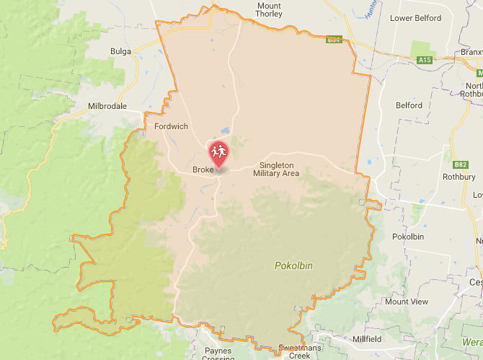

Kindergarten Enrolments

The school will make a place available for all students who live within the local intake area provided:
- They turn 5 on or before 31 July of the year of enrolment and produce a birth certificate. By law, all children must be enrolled in school by their sixth birthday.
- The sighting of a Certificate of Immunisation will be requested.

Enrolment of Students with Special Needs

This will be done in collaboration with carers/parents, school and District Office personnel after careful consideration of all options available to meet the student’s particular needs.
All parties must be satisfied that the student can be adequately catered for before the student is enrolled.
This enrolment must be in line with the Enrolment of Children with Disabilities Policy

Short Term and Partial Attendance

Short term enrolments will be accepted:
- Should the student be residing temporarily in our School Zone
Where the period is no more than one term or no more than 2.5 days per week, the student should not be enrolled, but regarded as being on Short Term attendance.
The home school should maintain the student’s name on the attendance register, with a note to the effect that the student is attending another school
A notice of Short Term Attendance will be sent to the base school at the completion of the enrolment.

Enrolment Procedure

- The student’s birth certificate should be sighted and copied
- Proof of address supplied
- The principal will:
- Contact the previous school
- Request student background information and documents
- Check that the student resides in zone.
Note:
- No student who is under suspension can be enrolled.
- A student who has a documented record of pervious violent behaviour will not be automatically enrolled.
- The process of enrolment may take some time.
- The Student Information Booklet should be given to the parent

Enrolment Ceiling

Every NSW Public School is required to determine their school enrolment ceiling annually. The enrolment ceiling is based upon the total permanent teaching spaces and their usage. Demountable teaching spaces are not considered for determining the enrolment ceiling.

Enrolment Buffer

No additional accommodation (permanent or demountable) will be provided to cater for increased enrolments resulting from non-local placements.

Within the enrolment ceiling, a buffer will be determined to ensure that all students within the school intake area can be catered for. This buffer is then reserved for students within the intake zone and is based upon historical enrolment data and anticipated enrolments.

Broke Public School is currently operating above the enrolment ceiling and as a result is only able to accept students who are residing in zone.

Application for Non-Local enrolment

Parents may seek to enrol their child in the school of their choice.

Non-local students may only be accepted when the enrolment buffer is not in force and their enrolment into a particular class does not exceed the maximum size for that grade.

Application for non-local enrolment above the enrolment ceiling will be determined by the Director, Public Schools NSW.

Appeals

Parents are able to appeal a decision and must contact the Director, Public Schools NSW located in Maitland District Office.

